SUPPLEMENTARY MATERIAL
Data Note: A high-quality, long-read genome assembly of the endangered ring-tailed lemur (Lemur catta)

Marc Palmada-Flores^{1,*}, Joseph D. Orkin^{1,2,*}, Bettina Haase³, Jacquelyn Mountcastle³, Mads F. Bertelsen^{4,5}, Olivier Fedrigo³, Lukas Kuderna¹, Erich D. Jarvis^{3,5,6}, Tomas Marques-Bonet^{1,8,9,10}

Table S1: Continuity metrics of human (hg38) and Lemur catta (mLemCat1) assemblies
Continuity metric | mLemCat1 (Lemur catta) | hg38 (Homo sapiens)
Scaffold L50 | 9 | 9
Scaffold N50 (bp) | 93,279,816 | 145,138,636
Scaffold L90 | 24 | 21
Scaffold N90 (bp) | 30,322,482 | 58,617,616
Scaffold L95 | 28 | 24
Scaffold N95 (bp) | 21,924,082 | 46,709,983
Span (Gb) | 2,122,351,751 | 3,209,286,105

Table S2: Comparison of scaffold N50 and assembly size of the latest primate genomes published in GigaScience
QUALITY CATEGORY | QUALITY METRIC | mLemCat1 (Lemur catta) | Ma2 (Macaca nemestrina) | Panubis1.0  (Papio anubis) | ASM756505v1 (Rhinopithecus roxellana)
Continuity | Scaffold N50 (Mbp) | 91.0 | 127.5 | 140.3 | 144.6
 | Span (Gbp) | 2.12 | 2.92 | 2.87 | 3.04
Reference |  | This study | [27] | [28] | [29]

Table S3: Repetitive elements identified by RepeatMasker in the L. catta genome assembly (mLemCat1)
Repetitive element |  | Number of elements* | Length occupied (bp) | Percentage of the assembly (%)
SINEs: |  | 975773 | 171088228 | 8.06
 | ALUs | 303773 | 77664585 | 3.66
 | MIRs | 656039 | 91335591 | 4.30
LINEs: |  | 1140393 | 511474252 | 24.10
 | LINE1 | 595053 | 359987847 | 16.96
 | LINE2 | 465779 | 129265242 | 6.09
 | L3/CR1 | 59050 | 14804438 | 0.70
LTR elements: |  | 872104 | 209147736 | 9.85
 | ERVL | 212537 | 55382958 | 2.61
 | ERVL-MaLRs | 252313 | 78358817 | 3.69
 | ERV_classI | 251370 | 47454116 | 2.24
 | ERV_classII | 22361 | 2590738 | 0.12
DNA elements: |  | 1169425 | 169044000 | 7.96
 | hAT-Charlie | 543135 | 72642558 | 3.42
 | TcMar-Tigger | 187193 | 44370166 | 2.09
Unclassified: |  | 105680 | 7178032 | 0.34
Total interspersed repeats: |  |  | 1067932248 | 50.32
Small RNA: |  | 129977 | 6609680 | 0.31
Satellites: |  | 60643 | 3268960 | 0.15
Simple repeats: |  | 322577 | 14421376 | 0.68
Low complexity: |  | 51933 | 2682469 | 0.13
Most repeats fragmented by insertions or deletions have been counted as single elements.

Table S4: Primate assembly lengths and respective quantifications of their Alu content
Genome ID | hg38 | panTro6 | gorGor6 | ponAbe3 | rheMac10 | calJac4 | Mmur_3.0 | mLemCat1
Species | Homo sapiens | Pan troglodytes | Gorilla gorilla | Pongo abelii | Macaca mulatta | Callithrix jacchus | Microcebus murinus | Lemur catta
Assembly span (Gb) | 3,21 | 3,05 | 3,04 | 3,07 | 2,97 | 2,90 | 2,49 | 2,12
Assembly span excluding Ns (Mb) | 3049,32 | 3018,59 | 2999,03 | 3043,44 | 2936,89 | 2859,82 | 2386,35 | 2105,70
Alu elements counts | 1234675 | 1171324 | 1133522 | 1178114 | 1236178 | 1234909 | 504507 | 301914
Alu total length (Mb) | 325,00 | 307,54 | 298,67 | 305,62 | 326,12 | 313,01 | 132,97 | 77,77
Portion of the assembly masked as Alu element (%) | 10,13 | 10,08 | 9,81 | 9,97 | 10,98 | 10,80 | 5,52 | 3,66
Alu count/Mb | 404,90 | 388,04 | 377,96 | 387,10 | 420,91 | 431,81 | 211,41 | 143,38

Table S5: Alu-monomers and Alu subfamilies count in each assembly
Assembly ID | Species | FAM | FRAM | FLAM | AluJ | AluS | AluY | Alu | Total elements
hg38 | Homo sapiens | 4168 | 6441 | 42449 | 286811 | 766701 | 159853 | 9069 | 1275492
panTro6 | Pan troglodytes | 3910 | 6254 | 40408 | 274933 | 728711 | 146542 | 9284 | 1210042
gorGor6 | Gorilla gorilla | 3896 | 6139 | 39402 | 265928 | 704610 | 142210 | 7964 | 1170149
ponAbe3 | Pongo abelii | 3895 | 6182 | 40289 | 273303 | 729945 | 149054 | 13681 | 1216349
rheMac10 | Macaca mulatta | 3919 | 6110 | 39606 | 267762 | 708793 | 244682 | 9091 | 1279963
calJac4 | Callithrix jacchus | 4143 | 5815 | 38049 | 252655 | 940025 | 28283 | 11194 | 1280164
Mmur_3.0 | Microcebus murinus | 3549 | 5079 | 21194 | 222843 | 255932 | 13934 | 5221 | 527752
mLemCat1 | Lemur catta | 2996 | 4754 | 17997 | 171397 | 110563 | 6967 | 1827 | 316501

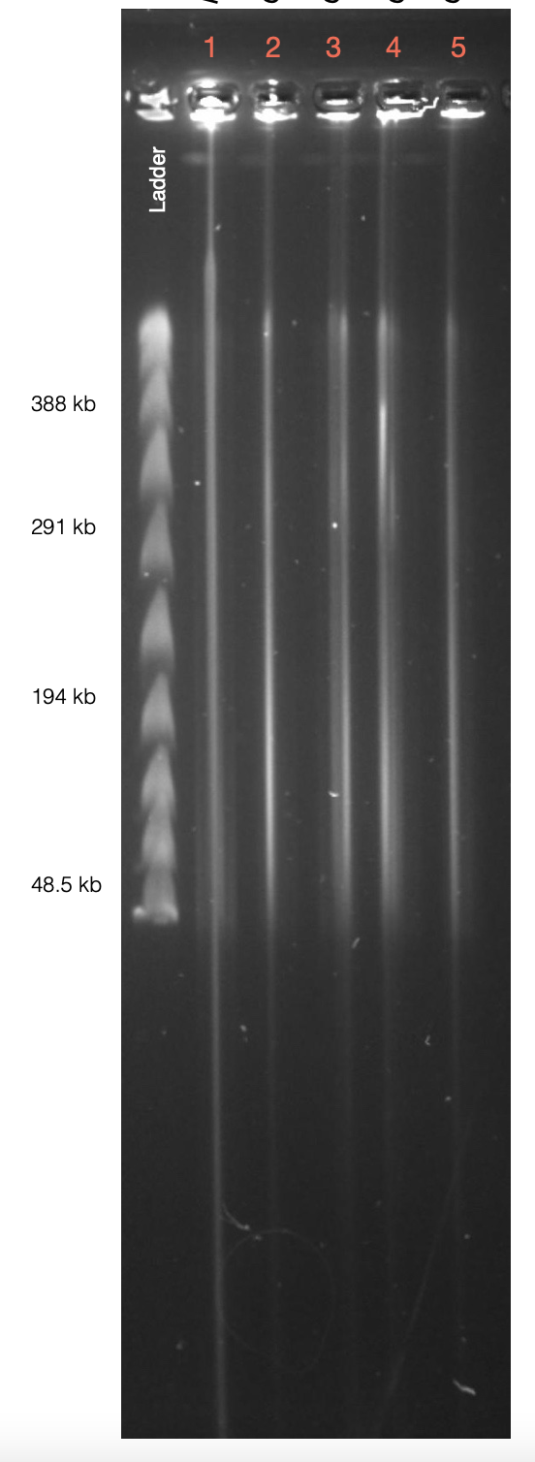

Figure S1: Pulse Field Gel assay (Sage Pippin Pulse) used for quality control of the ultra-High Molecular Weight DNA (Lemur catta is on well number 1)
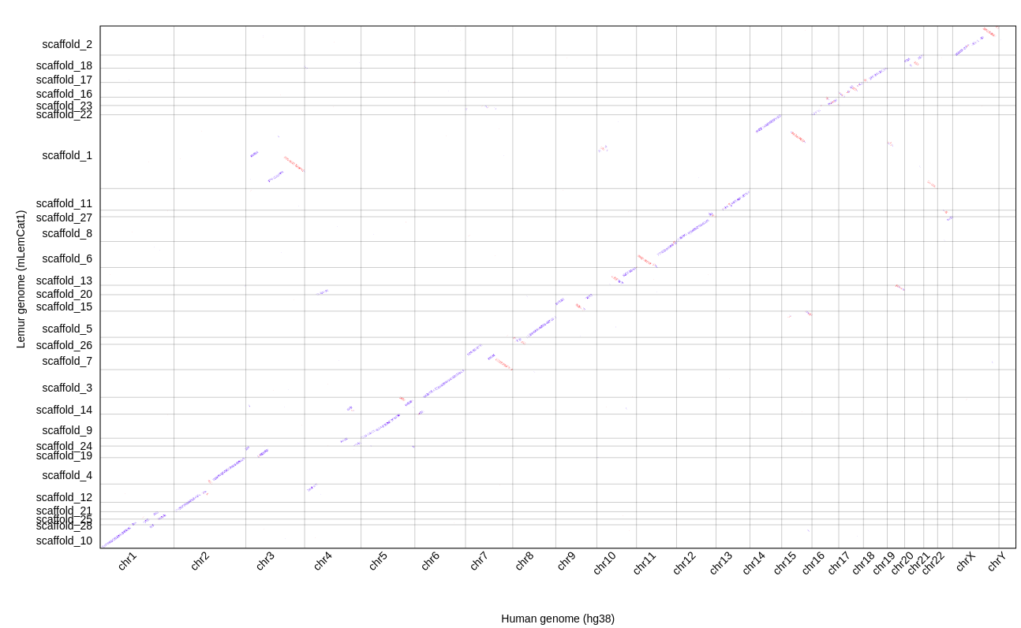
Figure S2: A chromosomal overall synteny plot between Lemur catta (mLemCat1 assembly; vertical axis) and Homo sapiens (hg38 assembly; horizontal axis)
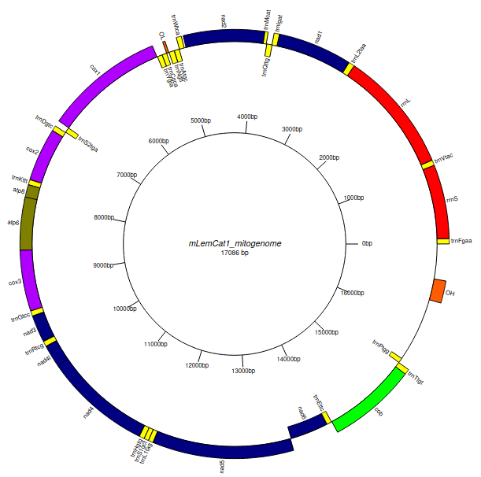
Figure S3: Representation of the Lemur catta mitogenome (mLemCat1.MT.20190820). Any genomic element annotated in the direct strand is represented in the outer layer and the ones present in the reverse strand in the inner layer.

